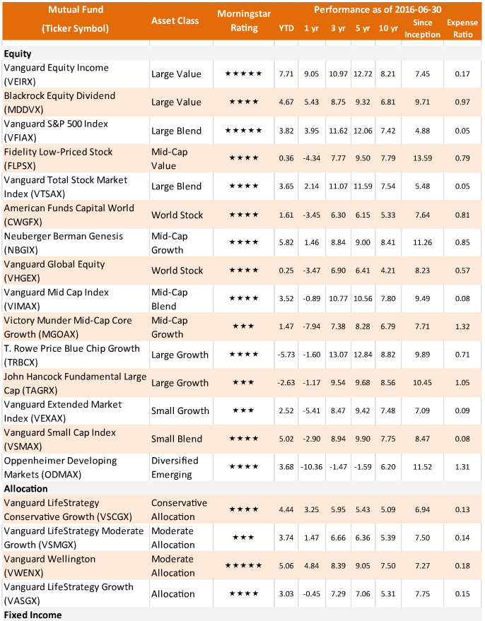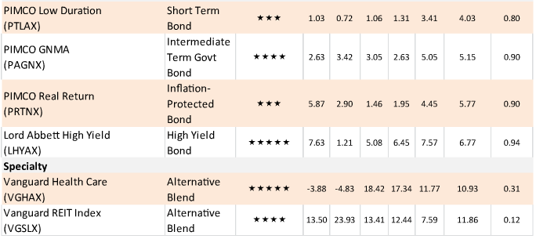
D

D

D

A
C

B
B
B
B
B
B
A
A
A
A
Has a redemption fee

